Communication on Progress - The Swedish Environmental Objectives with their connection to SDG

COMPANY:

OBJECTIVES | DESCRIPTION | CONNECTION TO SDG | COMMENT
Reduced Climate Impact | In accordance with the UN Framework Convention on Climate Change, concentrations of greenhouse gases in the atmosphere must be stabilised at a level that will prevent dangerous anthropogenic interference with the climate system. This goal must be achieved in such a way and at such a pace that biological diversity is preserved, food production is assured and other goals of sustainable development are not jeopardised. Sweden, together with other countries, must assume responsibility for achieving this global objective. | 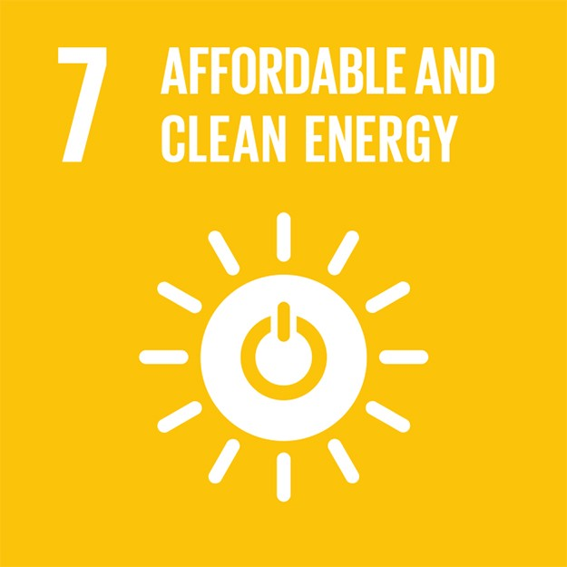  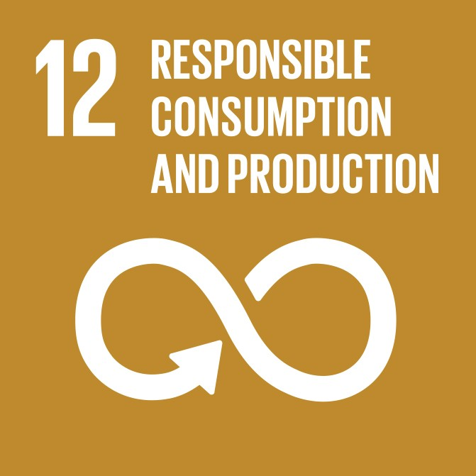  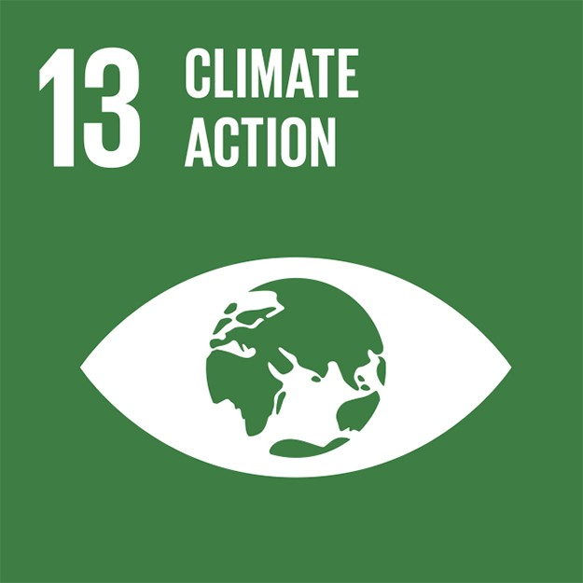 | [write your comments]  [write your comments]  [write your comments]
Clean Air | "The air must be clean enough not to represent a risk to human health or to animals, plants or cultural assets." | 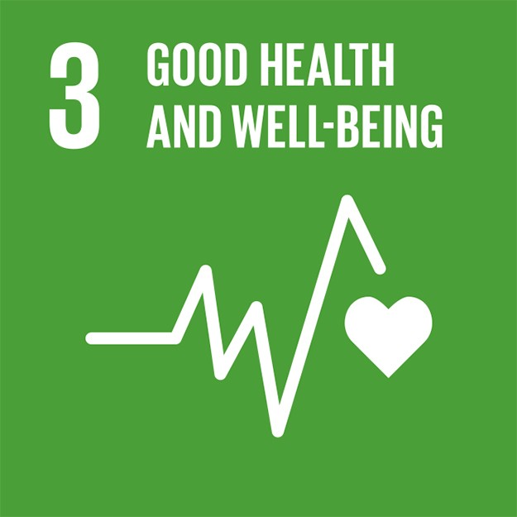  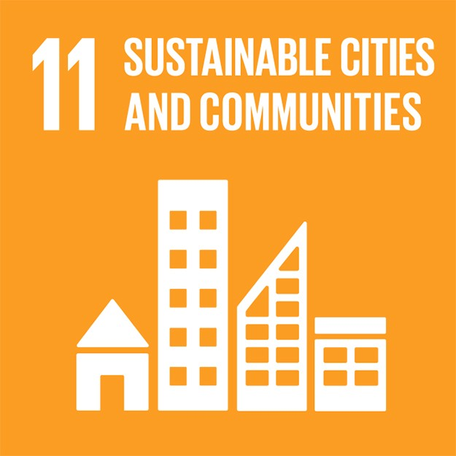 | [write your comments]  [write your comments]
Natural Acidification Only | "The acidifying effects of deposition and land use must not exceed the limits that can be tolerated by soil and water. In addition, deposition of acidifying substances must not increase the rate of corrosion of technical materials located in the ground, water main systems, archaeological objects and rock carvings." | 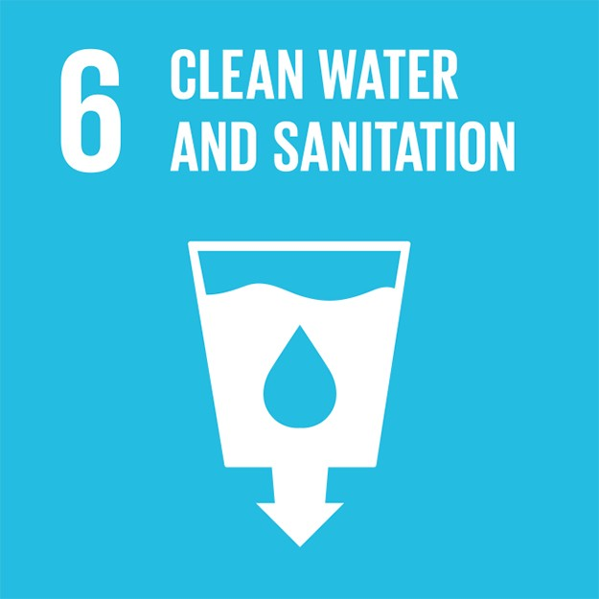  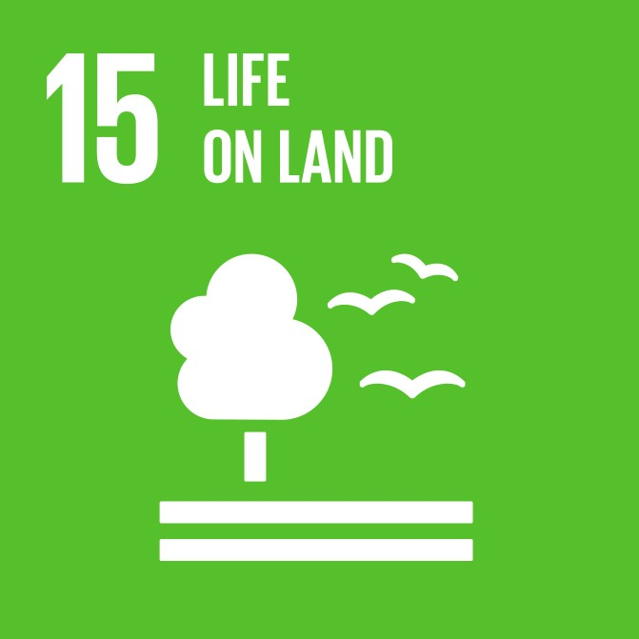 | [write your comments]  [write your comments]

A Non-Toxic Environment | "The occurrence of man-made or extracted substances in the environment must not represent a threat to human health or biological diversity.  Concentrations of non-naturally occurring substances will be close to zero and their impacts on human health and on ecosystems will be negligible. Concentrations of naturally occurring substances will be close to background levels." | 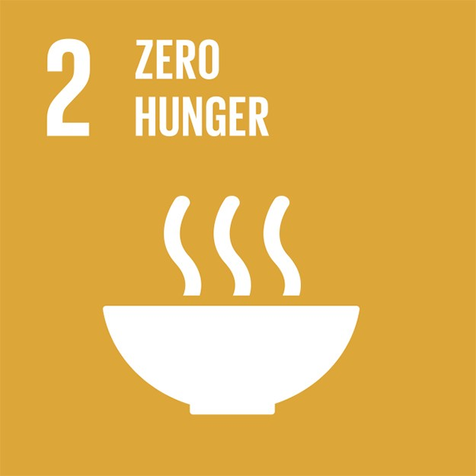  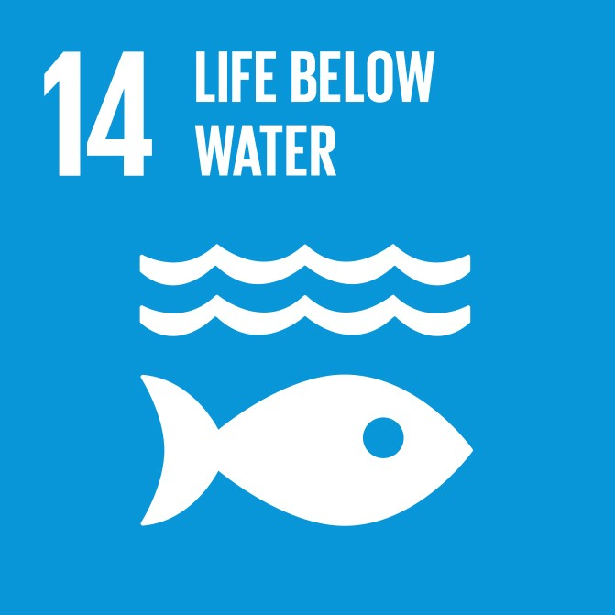 | [write your comments]  [write your comments]
 |  |  | [write your comments]
 |  |  | [write your comments]
 |  |  | [write your comments]
 |  |  | [write your comments]
 |  |  | [write your comments]
A Protective Ozone Layer | "The ozone layer must be replenished so as to provide long-term protection against harmful UV radiation." |  | [write your comments]
 |  |  | [write your comments]

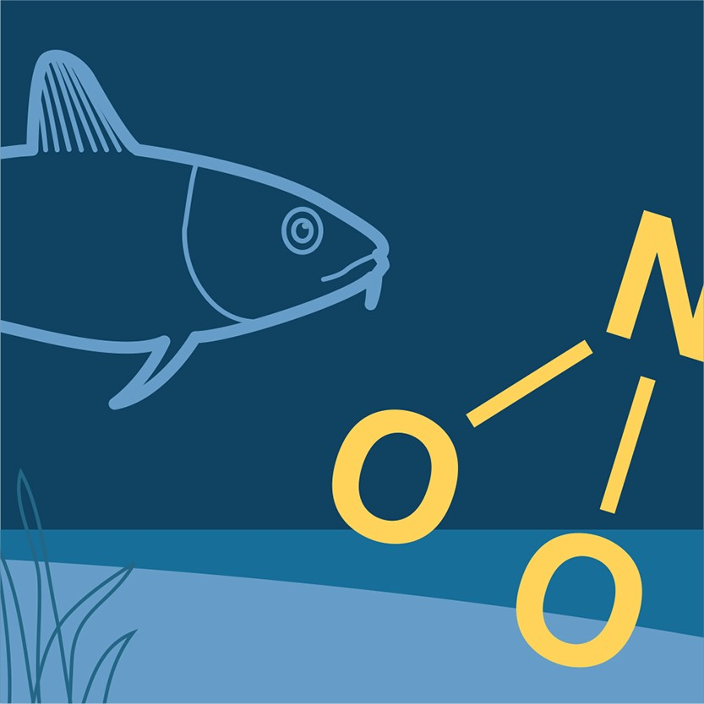

A Safe Radiation Environment | "Human health and biological diversity must be protected against the harmful effects of radiation." |  | [write your comments]  [write your comments]
Zero Eutrophication | "Nutrient levels in soil and water must not be such that they adversely affect human health, the conditions for biological diversity or the possibility of varied use of land and water." |  | [write your comments]  [write your comments]
Flourishing Lakes and Streams | "Lakes and watercourses must be ecologically sustainable and their variety of habitats must be preserved. Natural productive capacity, biological diversity, cultural heritage assets and the ecological and water-conserving function of the landscape must be preserved, at the same time as recreational assets are safeguarded." |  | [write your comments]  [write your comments]
Good-Quality Groundwater | "Groundwater must provide a safe and sustainable supply of drinking water and contribute to viable habitats for flora and fauna in lakes and watercourses." |  | [write your comments]  [write your comments]  [write your comments]

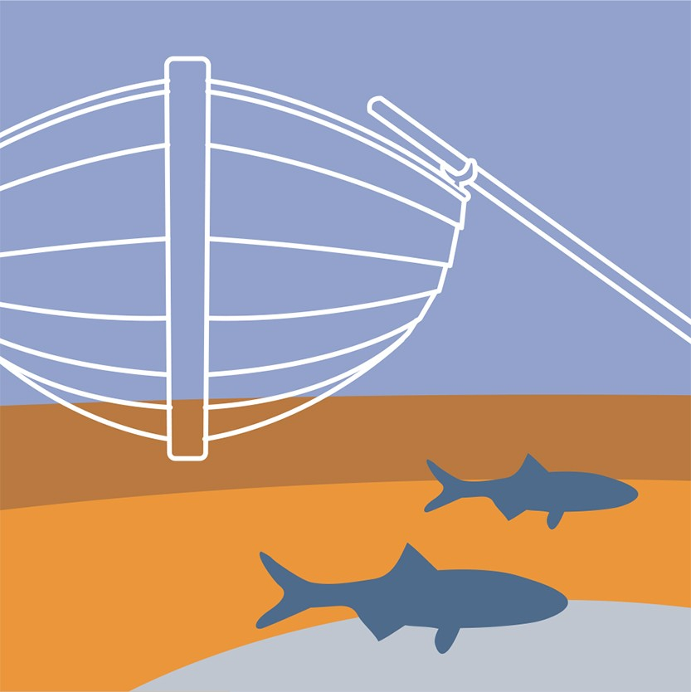
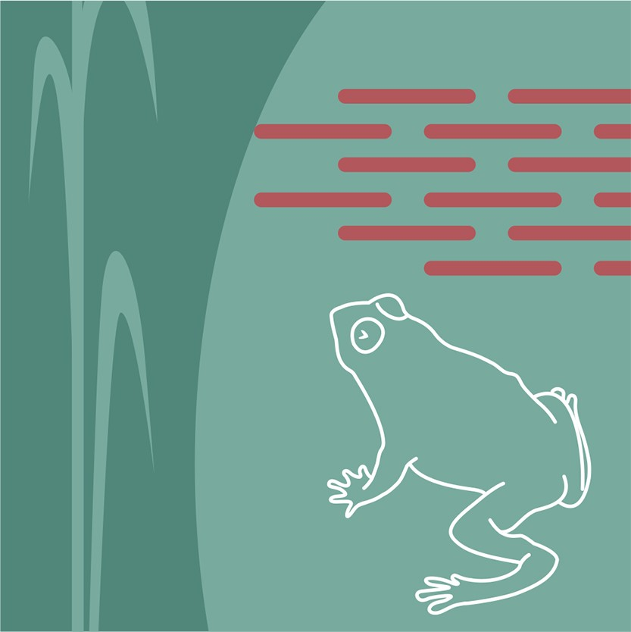

A Balanced Marine Environment Flourishing Coastal Areas and Archipelagos | "The North Sea and the Baltic Sea must have a sustainable productive capacity, and biological diversity must be preserved. Coasts and archipelagos must be characterized by a high degree of biological diversity and a wealth of recreational, natural and cultural assets. Industry, recreation and other utilization of the seas, coasts and archipelagos must be compatible with the promotion of sustainable development. Particularly valuable areas must be protected against encroachment and other disturbance.". |  | [write your comments]  [write your comments]
Thriving Wetlands | "The ecological and water- conserving function of wetlands in the landscape must be maintained and valuable wetlands preserved for the future." |  | [write your comments]  [write your comments]
Sustainable Forests | "The value of forests and forest land for biological production must be protected, at the same time as biological diversity and cultural heritage and recreational assets are safeguarded." |  | [write your comments]
A Varied Agricultural Landscape | "The value of the farmed landscape and agricultural land for biological production and food production must be protected, at the same time as biological diversity and cultural heritage assets are preserved and strengthened." |  | [write your comments]  [write your comments]

A Magnificent Mountain Landscape | "The pristine character of the mountain environment must be largely preserved, in terms of biological diversity, recreational value, and natural and cultural assets. Activities in mountain areas must respect these values and assets, with a view to promoting sustainable development. Particularly valuable areas must be protected from encroachment and other disturbance." |  | [write your comments]
A Good Built Environment | "Cities, towns and other built-up areas must provide a good, healthy living environment and contribute to a good regional and global environment. Natural and cultural assets must be protected and developed.  Buildings and amenities must be located and designed in accordance with sound environmental principles and in such a way as to promote sustainable management of land, water and other resources.". |  | [write your comments]  [write your comments]
 |  |  | [write your comments]
 |  |  | [write your comments]

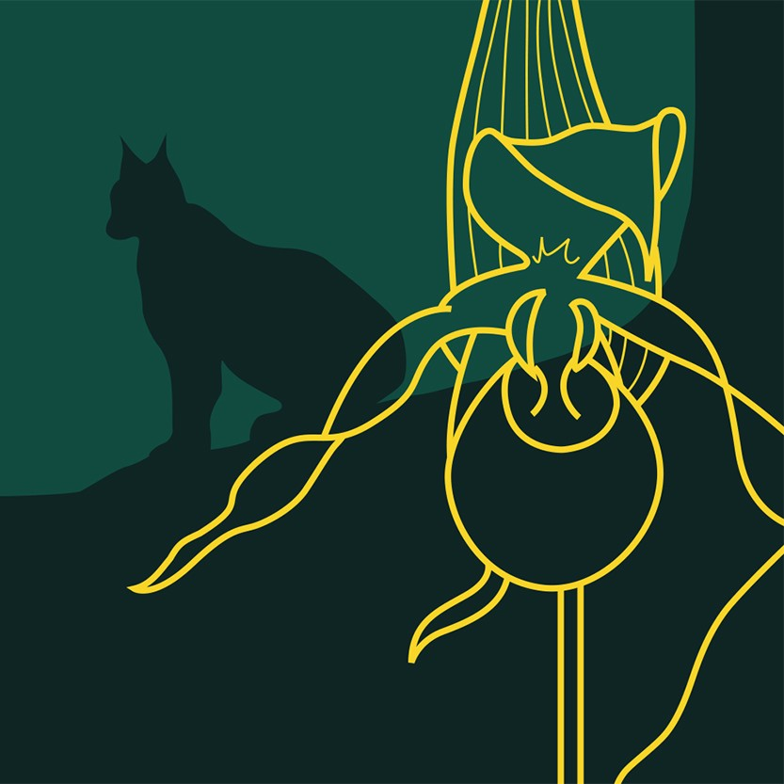

A Rich Diversity of Plant and Animal Life | "Biological diversity must be preserved and used sustainably for the benefit of present and future generations. Species habitats and ecosystems and their functions and processes must be safeguarded. Species must be able to survive in long- term viable populations with sufficient genetic variation.  Finally, people must have access to a good natural and cultural environment rich in biological diversity, as a basis for health, quality of life and well-being." |  | [write your comments]  [write your comments]  [write your comments]
 |  |  | [write your comments]
 |  |  | [write your comments]
The generational goal | The overall goal of Swedish environmental policy is to hand over to the next generation a society in which the major environmental problems in Sweden have been solved, without increasing environmental and health problems outside Sweden’s borders. |  | [write your comments]  [write your comments]
 |  |  | [write your comments]
 |  |  | [write your comments]

[write your comments]

[write your comments]

[write your comments]

[write your comments]

[write your comments]

[write your comments]

[write your comments]

EDIT

